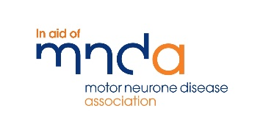
SPORT CENTRAL WALKING FOOTBALL TOURNAMENT JUNE 2022
In aid of Motor Neurons Disease
Name:  D.O.B: | Name:  D.O.B:
Address:  Postcode: | Address:  Postcode:
Tel No. | Tel No.
Mob No. | Mob No.
Email: | Email:
Team Manager Assistant Manager
Team Name:
Squad Players name D.O.B Tel No
I accept full responsibility for my team to fulfil all fixtures for the competition. I accept that once fixtures confirmed and team allocated, I cannot withdraw until a replacement team is found. I agree to abide by the competition rules and can confirm all participants are over the age of 18.
Managers signature
Date
Print Name
Please return to: Bianca.luttman@mkcollege.ac.uk , Tel no- 01908 684200
Office use ONLY
Date received: Payment received Info Sent
8-A-Side Walking Football Tournament
After running a Walking Football session for the last 5 year, we are looking forward to running a walking football tournament in aid of MND, with a member of our being diagnosed it has hit us all on how much this disease effects peoples lives and how quickly it can change your whole world.
We would like to invite you to join us for a fun filled day with a BBQ, Licenced bar, Stalls and lots of football in a day to raise money and show our support to the local MND branch.
- The tournament will be held at Sport Central MK, 4G Pitch- Sport Central, Elder Gate, Milton Keynes, MK91EN
- Tournament entry price is £100 per team
- Matches will take place on Saturday 25th June 2022.
- Adults (18 of over), Tournament 8-a-side with 2 subs allowed
- Group matches will be 20 minutes per game.
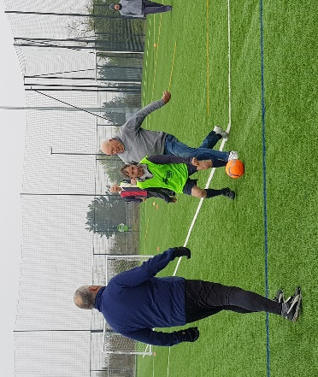
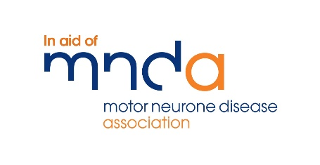
- Limited spaces available

To enter please complete the entry form and return to Bianca.luttman@mkcollege.ac.uk before June 10th.
Contact number: 01908 684200

